Additional file 2
Plasmid construction
The plasmid for KmYME disruption cassette was constructed as following. KmYME Open reading frame (ORF) was ampliﬁed from the genomic DNA of K. marxianus NBRC1777 with primer pairs KmYME-F and KmYME-R (Additional file 2: Table S1) and inserted into pGEM-T easy (Promega Corporation, Madison, WI, USA) to obtain pWD001. Then, the resultant plasmid pWD001 was linearized to remove a 120 bp sequence of KmYME ORF by PCR using primer pairs KmYME-F2 and KmYME-R2 (Additional file 2: Table S1, Fig. S1). A ScURA3 gene expression cassette was amplified with primer pairs ScURA3-SMAI-FULL-F and ScURA3-SMAI-FULL-R (Additional file 2: Table S1) using genomic DNA of S. cerevisiae W303 1A as temperate. After the ScURA3 fragment was digested by SmaI, it was inserted into linearized pWD001 to obtain plasmid pWD002 in which part of KmYME ORF was substituted by ScURA3 expression cassette. pWD002 was used to amplify the disruption cassette of KmYME (Additional file 2: Fig. S1). The plasmid pWD024 and pWD025 for disruption cassettes of KmYME homologous genes in S. cerevisiae (NP_011545 and NP_011529) were constructed similar as pWD002.

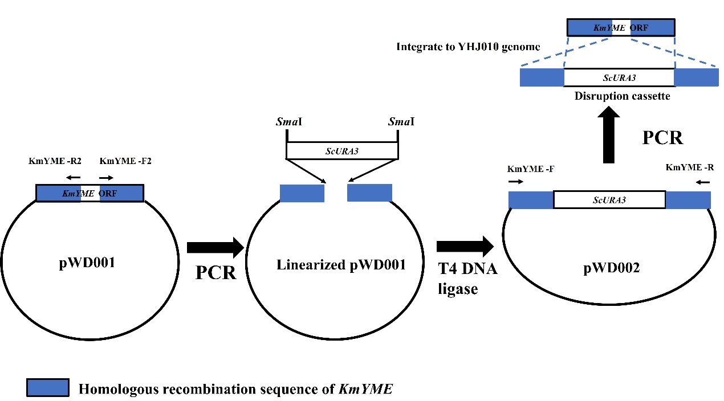
Fig. S1 Construction of disruption cassette of KmYME. The fragment containing KmYME with part of ORF frame removed was amplified with PCR from pWD001 and ligated with a ScURA3 expression cassette. The resultant plasmid pWD002 was used to amplify the KmYME disruption cassette.

The plasmid for KmYME overexpression was constructed as following. Full length DNA of KmYME ORF was ampliﬁed from pWD001 using the primer pairs KmYME-EcoRI-F and KmYME-NotI-R (Additional file 2: Table S1). Then the ORF was inserted into plasmid YEGAP [1] between the EcoRI and NotI sites to obtain the plasmid pWD003 which was used to overexpress KmYME in K. marxianus YHJ010.
The plasmids of fluorescence protein fusion for intracellular location were constructed as following. The expression cassettes of KmYME-EGFP and KmCox-RFP were obtained by fusing KmYME with EGFP and fusing KmCox with RFP respectively. KmYME ORF without stop codon was obtained from pWD001 using primer pairs KmYME-EcoRI-F and KmYME-fusion-R. EGFP ORF was obtained from pCG [2] using primer pairs EGFP-fusion-F and EGFP-NotI-R. Then KmYME-EGFP fused fragment was obtained by overlap extension PCR with KmYME-EcoRI-F and EGFP-NotI-R primers pair. KmCox ORF without stop codon was amplified from the genomic DNA of K. marxianus NBRC1777 with primer pair KmCox-EcoRI-F and KmCox-fusion-R. RFP ORF amplified from pCF.1676 [3] with RFP-fusion-F and RFP-NotI-R primer pairs. Subsequently, KmCox-RFP fused fragment was obtained through overlap extension PCR with KmCox-EcoRI-F and RFP-NotI-R as primers pair. Then KmYME-EGFP fragment or KmCox-RFP fragment was digested by EcoRI and NotI and then inserted into YEUKmPGK [4] or YEGAP between the EcoRI and NotI sites to obtain the plasmid pWD005 and pWD006, respectively. pWD005 and pWD006 were used to express fusion protein in K. marxianus to locate KmYME. After digested by EcoRI and NotI, EGFP ORF was inserted into YEUKmPGK between the EcoRI and NotI sites to obtain the plasmid pWD004 which was used to express EGFP. KmCox-RFP fragment was digested by EcoRI and NotI and then inserted into YEUKmPGK to obtain the plasmid pWD026 which was used to express Cox-RFP with URA3 selection marker to observe mitochondrial morphology.
The plasmids used to determine the mitochondrial signal peptide of KmYME were constructed as following. The plasmids for expression of truncated KmYME (1-20 aa)-EGFP and KmYME (1-40 aa)-EGFP were constructed with the frame of plasmid pWD004 using primer pairs EGFP-F3 and KmYME-R3, EGFP-F4 and KmYME-R4, respectively. Then the linearized plasmids were ligated using Exnase II (Vazyme Biotech Co., Ltd, Nanjing, China). The resultant plasmids were named pWD007 and pWD008 (Additional file 2: Fig. S2). Likewise, KmYME (41-360 aa)-EGFP fragment was ampliﬁed from pWD004 with KmYME-EcoRI-F2 and EGFP-NotI-R, then digested by EcoRI and NotI and inserted into YEUKmPGK between the EcoRI and NotI sites to obtain the plasmid pWD009.
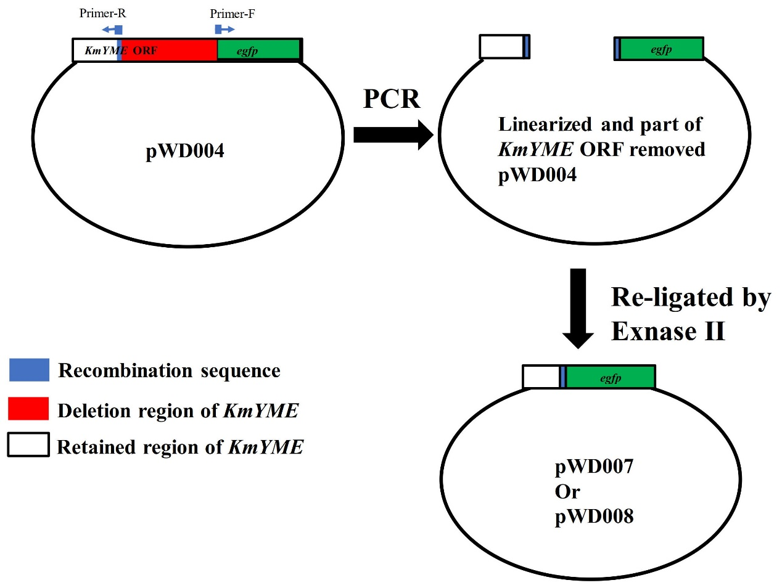
Fig. S2 Construction of the plasmid for KmYME mitochondrial signal peptide determination.

The plasmid used to express KmYME in E. coli was constructed as following. KmYME ORF was ampliﬁed from pWD001 with KmYME-NdeI-F and KmYME-XhoI-R. The fragment was inserted into NdeI and XhoI digested pET22b to obtain the plasmid pWD010.
The plasmids for expression of KmYME mutants were constructed through site-directed mutagenesis of GXSXG motif as following. The amino acid residues GYSLG in KmYME were replaced with GHSMG or AYALA using PCR-based amplification of the entire pWD003 and pWD010 construct. The primer pairs KmYME-H-F and KmYME-H-R were used to change GYSLG into GHSMG. And the primer pairs KmYME-A-F and KmYME-A-R were used to change GYSLG mutant into AYALA. Then the fragments were ligated using Exnase II. The plasmids containing the mutant of KmYME were named as pWD032 (GYSLG→GHSMG in pWD003), pWD033 (GYSLG→AYALA in pWD003), pWD034 (GYSLG→GHSMG in pWD010), pWD035 (GYSLG→AYALA in pWD010).

Strains construction
KmYME disrupted strain was constructed as following. The disruption cassette of KmYME was amplified with primers KmYME -F/R (Additional file 2: Table. S1) from plasmid pWD002 (Table 4) and then transformed into YHJ010. The transformants were screened on SD medium without Uracil. The obtained strain in which KmYME was disrupted was named YWD001 (Table 1 and Fig. 3). The ScURA3 expression cassette, which was the selection marker for disruption cassette, was transformed into YHJ010 to obtain the non-disruption control strain YWD005 (Table 1 and Fig. 3).
In order to overexpress KmYME, linearized pWD003 (Table 4) was transformed into YHJ010 and screened on SD medium without tryptophan and KmYME overexpression strain YWD002 was obtained (Table 1 and Fig. 3). The TRP1 expression cassette was then transformed into YHJ010 to construct non- overexpression strain YWD009 (Table 1 and Fig. 3). pWD003 (Table 4) was linearized and transformed into strain YWD001 to construct KmYME retro-complementation strain YWD004 (Table 1 and Fig. 3). pWD032 and pWD033 (Table 4) which contained the mutants of KmYME were also transformed into YWD001 to obtain YWD074 and YWD076, respectively. Empty plasmid YEGAP [1] was linearized and transformed into YWD001 and YWD005 to obtain YWD003 and YWD010, respectively.
To determine the location of KmYME, the strains co-expression of EGFP and KmCox-RFP (control strain) or co-expression of KmYME-EGFP and KmCox-RFP were constructed. Specifically, K. marxianus YHJ010 was transformed with linearized plasmid pWD004 and pWD006 to obtain strain YWD024 in which EGFP and KmCox-RFP were co-expressed as a control. On the other hand, K. marxianus YHJ010 was subsequently transformed with linearized pWD005 and pWD006 to obtain strain YWD026 (Table 1 and Fig. 3) in which KmYME-EGFP and KmCox-RFP were co-expressed to determine KmYME intracellular location.
To determine the mitochondrial signal peptide of KmYME, the strains expressing various truncated KmYME fused with EGFP were constructed. K. marxianus YHJ010 was transformed with plasmid pWD004, pWD005, pWD007, pWD008 or pWD009 to obtain YWD021, YWD022, YWD028, YWD030, or YWD032, corresponding to the expression of EGFP, KmYME (full length)-EGFP, KmYME (1-20 aa)-EGFP, KmYME (1-40 aa)-EGFP, and KmYME (41-360 aa)-EGFP, respectively (Table 1 and Fig. 3).
To observe the mitochondrial morphological, the strains expressing KmCox-RFP were constructed to assist the mitochondria detection. A ScURA3 disruption cassette was ampliﬁed from pMD18T-ΔScURA3 [5] and transformed into YWD003, YWD004, and YWD010 to disrupt ScURA3 and selected on an SD plate containing uracil and 0.1% 5’-ﬂuoro-orotic acid (5’-FOA). Next, the obtained positive strains were transformed with linearized pWD026 (Table 4) to obtain YWD046, YWD047, and YWD048, respectively. YWD046, YWD047, and YWD048 expressed KmCox-RFP in KmYME disrupted strain, KmYME retro-complement stain and KmYME non-disruption stain (wild type control), respectively (Table 1 and Fig. 3).
The homologous genes of KmYME in S. cerevisiae were also disrupted. The gene NP_011545 or NP_011529 disruption cassettes were amplified with primer pairs NP_011545-F/R or NP_011529-F/R (Additional file 2: Table. S1) from plasmid pWD024 or pWD025 and then transformed into S. cerevisiae W303 1A. Strains YWD034 and YWD036 were obtained (Table 1 and Fig. 3). To obtain double disruption strain, the ScURA3 in YWD034 was disrupted through transformed by a ScURA3 disruption cassette which was ampliﬁed from pMD18T-ΔScURA3. The ScURA3 re-disrupted strain was selected on an SD plate containing uracil and 0.1% 5’-ﬂuoro-orotic acid (5’-FOA). Then the obtained strain YWD037 was transformed by NP_011529 disruption cassette to obtain double disruption stain YWD038. The non-disruption control strain YWD040 was obtained through transformation of S. cerevisiae W303 1A with ScURA3 expression cassette (Table 1 and Fig. 3). To evaluate if KmYME could rescue the decreased inhibitors tolerance of double disruption strain of S. cerevisiae, linearized YEGAP or pWD003 was transformed into YWD038 and screened on SD plate supplied leucine, adenylate, and histidine, YWD051 (as non-overexpression control) and YWD052 (KmYME overexpression) were obtained. Then, linearized YEGAP was transformed into YWD040 and YWD053 was obtained (as non-disruption control) (Table 1 and Fig. 3).

Table S1 Primers used in this study
Primers | sequenceª
KmYME-F | 5’-ATGCTTCTCGCTTACACCGTCAG-3’
KmYME-R | 5’-TTAATCTCTAGCACTTTTGAGAG-3’
KmYME-EcoRI-F | 5’-AAAgaattcATGCTTCTCGCTTACACCGTCAG-3’
KmYME-NotI-R | 5’-ATAgcggccgcTTAATCTCTAGCACTTTTGAGAG-3’
KmYME-F2 | 5’-CAAGCAGCACTGAAACGTTCTGG-3’
KmYME-R2 | 5’-GACACAAAGCCTCGGAGGCATT-3’
ScURA3-SMAI-FULL-F | 5′-TCCcccgggTATTTAGAAAAATAAACAAATAG-3′
ScURA3-SMAI-FULL-R | 5′- TCCcccgggAATGCGTACTTATATGCGTC-3′
KmYME-fusion-R | 5’-GCTCACACTACCACTACCTGAACCATCTCTAGCACTTTTGAGAGAT-3’
EGFP-fusion-F | 5’AGAGATGGTTCAGGTAGTGGTAGTGTGAGCAAGGGCGAGGAGCTGTT-3’
EGFP-NotI-R | 5’-TTAgcggccgcTTACTTGTACAGCTCGTCCATGCC-3’
EGFP-EcoRI-F | 5’-GTAgaattcATGGTGAGCAAGGGCGAGGAGCTG-3’
KmCox-EcoRI-F | 5'-CTAgaattcATGTTGTCTCTACGTCAATCCCTAT-3'
KmCox-fusion-R | 5'-ACTACCACTACCTGAACCGTGGTGACCTTCTTGAGGAACACCC-3'
RFP-fusion-F | 5'-CACGGTTCAGGTAGTGGTAGTGTGTCTAAGGGCGAAGAGCTGAT-3'
RFP-NotI-R | 5'-CTTgcggccgcTCAATTAAGTTTGTGCCCCAGTT-3'
KmYME-R3 | 5’-GCATACTCTGGTTCAGGTAGTGGTAGTGTG-3’
EGFP-F3 | 5’-TACCTGAACCAGAGTATGCTCTTCTGGTAAAAG-3’
KmYME-R4 | 5’-CAAGGAAACTGGTTCAGGTAGTGGTAGTGTGAG-3’
EGFP-F4 | 5’-TACCTGAACCAGTTTCCTTGATTGGCAATGGC-3’
KmYME-EcoRI-F2 | 5’CTAgaattcATGGTCGATATGGCATATGATCTG3’
KmYME-NdeI-F | 5’-AGGAGATATAcatatgCTTCTCGCTTACACCGTC-3’
KmYME-XhoI-R | 5’-GTGGTGGTGctcgagATCTCTAGCACTTTTGAGAG-3’
NP_011545-F | 5’-CATCAGCAAGTGTCCGATGCCTTCTC-3’
NP_011545-F2 | 5’-TTAAAGGCAAGCGCCCCGGAGCAAG-3’
NP_011545-R | 5’-TGACGATCTTATCGTATGCATCAGC-3’
NP_011545-R2 | 5’-CATTGTACCGTTACCAATTCTCCTC-3’
NP_011529-F | 5’-GATCAGATTCACCGTCATGAGTGTAG-3’
NP_011529-F2 | 5’-GATTTTGAATAAAATCTTGATGTACG-3’
NP_011529-R | 5’-TATGTATAGTTCTCCTTCAAGGAGAC-3’
NP_011529-R2 | 5’-CATTTGTAAGCCCTCTTCCCACGG-3’
KmYME-H-F | 5’-CCTTGTGGGTCACTCTATGGGTGCTAAGGTTGCCATGCTTG-3’
KmYME-H-R | 5’-CCTTAGCACCCATAGAGTGACCCACAAGGTTAACCTTACCC-3’
KmYME-A-F | 5’-CTTGTGGCATATGCTTTGGCAGCTAAGGTTGCCATGCTTGCCTGTT -3’
KmYME-A-R | 5’-CTTAGCTGCCAAAGCATATGCCACAAGGTTAACCTTACCCAATG -3’
KmYME-RT-F | 5’ CCCTTGTGAAATCTTGCGTTAAGTTG3’
KmYME-RT-R | 5’ AATGTAGCATACCGTCGTCATAGTTG 3’
ACT1-RT-F | 5’TTGGCTGGTAGAGACATCACTGAC3’
ACT1-RT-R | 5’ AGCAGATGATTGAGAAGCGGTTTG 3’
ª The restriction enzyme site is bolded, italicized and underlined.

References

1. Hong J, Tamaki H, Akiba S, Yamamoto K, Kumagai H: Cloning of a gene encoding a highly stable endo-β-1,4-glucanase from Aspergillus niger and its expression in yeast. J Biosci Bioeng 2001, 92(5):434-441.
2. Hong J, Ye X, Wang Y, Zhang YHP: Bioseparation of recombinant cellulose-binding module-proteins by affinity adsorption on an ultra-high-capacity cellulosic adsorbent. Anal Chim Acta 2008, 621(2):193-199.
3. Li T, Zheng F, Cheung M, Wang F, Fu C: Fission yeast mitochondria are distributed by dynamic microtubules in a motor-independent manner. Sci Rep 2015, 5:11023-11023.
4. Yang C, Hu S, Zhu S, Wang D, Gao X, Hong J: Characterizing yeast promoters used in Kluyveromyces marxianus. World J Microbiol Biotechnol 2015, 31(10):1641-1646.
5. Zhang B, Zhang J, Wang D, Han R, Ding R, Gao X, Sun L, Hong J: Simultaneous fermentation of glucose and xylose at elevated temperatures co-produces ethanol and xylitol through overexpression of a xylose-specific transporter in engineered Kluyveromyces marxianus. Bioresour Technol 2016, 216:227-237.

